Test Description:

Challenge the functionality of "מצאו לי טיסות" in Flights "טיסות" function
Test Purpose: Test Run Instructions: <Describe any special instructions needed to execute this test>
Test Run Information:  Tester Name: Ariel  Date of Test: 17/11/2023 | Prerequisites for this test: None
Software Versions:
Application:
Browser: Chrome
Operating System: Win 10 Pro
Required Configuration: [ browser setup, security or user ID roles]
No special setup needed
NOTES and RESULTS:

 | TEST SCRIPT STEPS/RESULTS
 | STEP | TEST STEP/INPUT | EXPECTED RESULTS | ACTUAL RESULTS |  | PASS/FAIL
 | Sanity – Error handling – "הלוך ושוב" – מצאו לי טיסות
 |  | Be on page:  https://www.issta.co.il/ | Page opens | Page opens |  | PASS
 |  | Click on flights "טיסות" | Opens Flights functions | 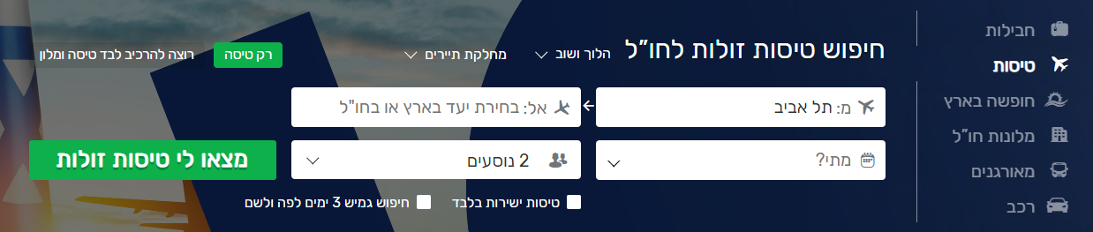 |  | PASS
 |  | Verify that default options are as stated  "הלוך ושוב", "2 מבוגרים" "מחלקת תיירים"  טיסות ישירות בלבד  חיפוש גמיש 3 ימים לפה ולשם  רק טיסה  as default | default | default |  | PASS
 |  | leave "המראה" as default location, "תל אביב" | default | default |  | PASS
 |  | Click on "מצאו לי טיסות" | Pop up message appear  "לא נבחר תאריך יציאה"  "לא נבחר תאריך חזרה"  "נא בחר יעד"  User is not able to proceed | 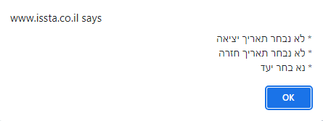  User is not able to proceed |  | PASS
 |  | Click on OK | Pop up closes | Pop up closes |  | PASS
 |  | Select valid destination "טוקיו יפן"  Leave "מתי?" empty | Selected  Appears in field | Selected  Appears in field |  | PASS
 |  | Select valid date "01/02/2024-29/02/2024"  Leave "אל" empty | Selected  Date Appears in field | Selected  Date Appears in field |  | PASS
 |  | Click on "מצאו לי טיסות" | Pop up message appear  "נא בחר יעד"  User is not able to proceed | 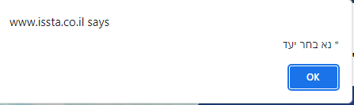 |  | PASS
 |  | Change number of passengers to 0  Reset all fields to default  And click "מצאו לי טיסות" | Pop up message appear  "לא נבחר תאריך יציאה"  "לא נבחר תאריך חזרה"  "יש לבחור מבוגר אחד לפחות"  "נא בחר יעד"  User is not able to proceed | 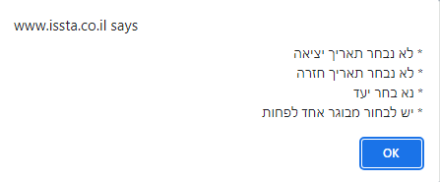 |  | PASS
 |  | Click on OK | Pop up closes | Pop up closes |  | PASS
 |  | Select valid destination in "אל"  טוקיו יפן | Selected  Appears in field | Selected  Appears in field |  | PASS
 |  | Click on "מצאו לי טיסות" | Pop up message appear  "לא נבחר תאריך יציאה"  "לא נבחר תאריך חזרה"  "יש לבחור מבוגר אחד לפחות"  User is not able to proceed | 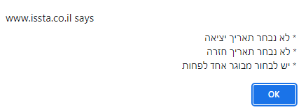 |  | PASS
 |  | Click on OK | Pop up closes | Pop up closes |  | PASS
 |  | Select a valid date in "מתי"  01/02/2024 – 29/02/2024 | Date selected and appear in field | Date selected and appear in field |  | PASS
 |  | Click on "מצאו לי טיסות" | Pop up message appear  יש לבחור מבוגר אחד לפחות""  User is not able to proceed | 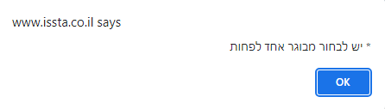 |  | PASS
 |  |  | <Optional> <Headline>
<Optional> <Headline>

